

**MTD220**

**User Experience (UX) Design and Web**

**Technologies**

**Tutor-Marked Assignment 01**

**January 2023 Presentation**

***TUTOR-MARKED ASSIGNMENT 01 (TMA01)***

This assignment is worth 15% of the final mark for MTD220 – User Experience (UX) Design and Web Technologies.

The cut-off date for this assignment is **15 February 2023, 23:55 hrs.**

Note to Students:

You are to include the following particulars in your submission: Course Code, Title of the TMA, SUSS PI No., Your Name, and Submission Date.

### Question 1

1. Explain in your own words, the two dimensions of “Usefulness” in UX in the context of digital interfaces.

In my own words, usefulness is the combination of both utility and usability. For any product to be successful, it has to be designed with this principle in mind. This is especially so for modern products such as websites or phone applications, as the users would need to interact with these services on a daily basis.

To gain a better understanding of Usefulness, we need to dissect this metric into its two component parts. Namely utility and usability. We will also be referring to Appendix A, to develop a framework such that we are better able to quantify our findings.

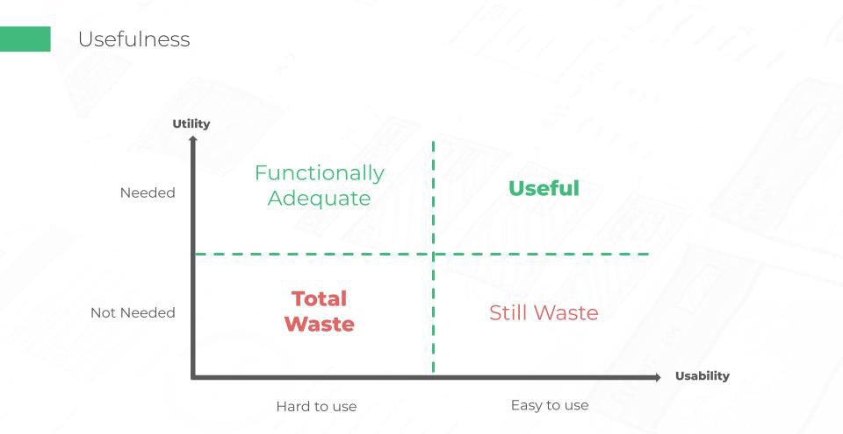

With regards to a product’s usability, there exists on the graph a vertical line which determines that the product is not usable at all. To make a product more usable, we should incorporate design thinking philosophies in mind when developing the user interface (UI) and carefully plan for the user experience (UX). For example, when developing applications for the elderly, buttons should be big and font sizes should be clearly legible and of a larger font size as well. This increases the product’s usability as the target audience can clearly navigate through the app with as little friction as possible.

Moving on to the utility function of the usefulness equation, it is equally important as a usable product is redundant if the user is not meaningfully engaged with the product’s capabilities. Imagine having developed the most user friendly application, but there isn’t any functionality within the application itself. This phenomenon will surely see users uninstall the application from their phone. For example, users who download a ride sharing application, will expect the utility function of being able to get a car ride at a moment’s notice. However, if the application doesn’t have the function that they’re looking for, this will prevent the user from engaging with the application in the future.

Hence, it is only when the product has fulfilled both utility and usability, can it be called a truly useful product.

* 1. marks)

1. Illustrate with **ONE (1)** example consisting of the two dimensions of “Usefulness” for a feature on a webpage/app. You need to provide a screenshot and reference the webpage/app to support your explanation.

The example that I have chosen would be the landing page for the Macdonald Application on the app store:

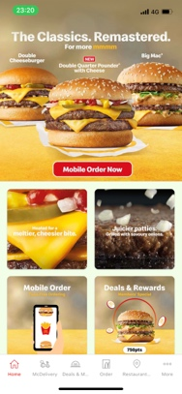

The rationale for this choice would be that Maconalds has identified several functions within the application that their users might need a quick access to. This application is also extremely easy to use whilst comprising of any and all user journeys needed. Hence, this is why I deem this page a useful page based on the two dimensions of “Usefulness”.

* 1. marks)

1. With reference to the webpage/app that you provided in 1 (b), you have been tasked to enhance the feature.

Provide **TWO (2)** research questions for each dimension of “Usefulness” that you might ask during the user research phase.

1. Utility:
   1. What other features do you want added to the Macdonalds application?
      1. This will allow us to identify if there are other pain points that our user faces that we have missed out while developing the application.
2. Usability:
   1. What are the first few steps that the user takes after launching the application?
      1. This question will allow us to map the first few steps of the every user’s journey when they enter the application. In the long run, with this data, we can better design the Macdonalds application such that it removes barriers of entry for our users from launching the application to checking out on the application.
   2. What are the pages that causes the user to log off the application?
      1. This question will allow us to identify which areas of the application that the UX/UI team has to optimize. This is with regards to the usability of the key friction areas within the Macdonald Application.
   3. marks)

1. The UX Stack is a universal framework that consists of key layers that fall into the UX design process of a digital project.

Highlight the UX Stack layers where the two dimensions of “Usefulness” can be found. Explain in your own words, what is in each UX Stack layer.

(10 marks)

# Question 2

Refer to Figure 2. You may refer to www.youtube.com homepage for reference as well. **Do note that you are only referencing the YouTube homepage for this question.**

## Figure 2

1. Using Jakob’s Ten Usability Heuristics, identify **THREE (3)** good examples in Figure 2 and explain why. You may support your answers with screenshots.
   1. marks)
2. User control and freedom – The current YouTube homepage is a clear showcase for the heuristic on “User Control and Freedom”. For example, if a user accidentally clicks or exits the current video, they are able to quickly look for the video in the “History” tab. This allows the user to have a clear and easy path back to undo their accidental action of leaving the video. This fosters a sense that they are the ones in control of the system, which ultimately prevents them from feeling stuck or frustrated at the system. Furthermore, users could also click on the bright red YouTube button to return to their recommended homepage which allows them to exit their current video.
3. Recognition rather than recall – The YouTube page achieves this heuristic through the act of cleverly making icons easily recognisable and the terms that they’ve chosen are easy to understand. Furthermore, recommended videos and categories are shown to the user based on past viewing trends and other data that YouTube has access to. This reduces the cognitive load needed to interact with YouTube’s website, hence, this reduces any potential frustration or friction that the users might face
4. Consistency and standards – The YouTube page has masterfully created a consistent and standardised website. This stretches from the fonts, font colour as well as details around its icons. This reduces the cognitive stress that the user might suffer if they had to wonder whether the words, fonts and colours might mean different things.
5. Using Jakob’s Ten Usability Heuristics, propose **THREE (3)** items that can be improved on in Figure 2. You may support your answers with screenshots.
6. Error prevention – Whenever a user is watching a video and accidentally clicks away either to the homepage or closing a tab, YouTube could have a prompt that asks the user if they are sure they want to exit the current video.
7. Flexibility and efficiency of use – YouTube could have keyboard shortcuts that allow users to quickly resume what they were doing before closing the tab or the webpage. This speeds up the interaction between the expert user and the YouTube webpage , whilst at the same time allowing the inexperienced users to carry on interacting with YouTube without being forced to learn these keyboard shortcuts.
8. Aesthetic and minimalist design – YouTube could benefit with a more minimalistic landing page. Currently, the user will be torn between too many options when they arrive to the landing page. Hence, YouTube could optimize this by only selecting videos that they predict the user will watch. Perhaps, they could limit the number of videos to 3 per row and reduce the size of the image boxes that the user might not want to watch. By doing this, the user’s focus will be on the relevant videos rather than on videos that they might not watch. Ultimately, this helps to reduce cognitive load and streamline the user’s focus into relevant videos.
   1. marks)

#### Question 3

Refer to the website shown in Figure 4. You may refer to https://www.youtube.com for this question.

### Figure 4

1. Explain in your own words, how and why you will apply design thinking to help you understandyour users.
2. Design thinking is a problem-solving framework that puts the end-user at the center of the design process. This method helps companies to understand and empathize with their users, identify their needs, and develop creative and practical solutions to meet those needs.

(4 marks)

1. Explain the difference between Qualitative and Quantitative research methods. Discuss and describe **ONE (1)** Qualitative research method and **ONE (1)** Quantitative method that you will use to understand your users with reference website shown in Figure 4. Explain why you think these are the best method(s) to use.

(10 marks)

(c) Explain in your own words, how and why you will apply design thinking to explore the ideas.

(6 marks)

(d) Propose **ONE (1)** enhancement to the website and explain how it will improve the experience of the website. Sketch out your enhancement (e.g., a user flow) in lowfidelity.

(10 marks)

#### Question 4

Refer to the website shown in Figure 4.

(a) Apply the design thinking process to construct a 4-phase customer journey map for the following scenario:

*Sammy wants to upload a video to YouTube and publish the video privately so that it is only available to her families and friends to view the video.*

You may reference this template:

<https://media.nngroup.com/media/articles/attachments/JMTemplate.pdf>

(23 marks)

(b) Explain in your own words, what the problem statement is and why it is important to define a meaningful, well-defined problem statement.

(4 marks)

(c) Define a problem statement from one of the insights of the 4-phase customer journey map that you have created in Question 4(a).

(3 marks)

**---- END OF ASSIGNMENT ----**